Unigraphics NX

Romi Galaxy 15M Mill-Turn

Postprocessor

Reference Guide



August / 2004

Customer Infromation
Company: |  | Fax.:
Contact: |  | E-mail:
Position: |  | Address:
Depto.:
Tel.:

GUIDELINE

This postprocessor was created using UG/Post Builder V3.2, based supplied CNC program sample and related docs.

 | Sent Files | Description
1 | romi_galaxy_15M_fanuc21_XZCmill_main.pui | Mill (main)
2 | romi_galaxy_15M_fanuc21_XZCmill_main.tcl | Z-axis Head Position
3 | romi_galaxy_15M_fanuc21_XZCmill_main.def
4 | romi_galaxy_15M_fanuc21_XZCmill_Xspindle.pui | Mill
5 | romi_galaxy_15M_fanuc21_XZCmill_Xspindle.tcl | X-axis Head Position
6 | romi_galaxy_15M_fanuc21_XZCmill_Xspindle.def
7 | romi_galaxy_15M_fanuc21_lathe.pui
8 | romi_galaxy_15M_fanuc21_lathe.tcl | Turn
9 | romi_galaxy_15M_fanuc21_lathe.def
10 | ude.txt | Post Command “??? ”
Note.:
- *.pui - UG/Post Builder File
- *.tcl - Event Handler
- *.def - Definition File

WARNING: KEEP BACKUP COPY OF THE SENT FILES!
Postprocessor Data

Machine Information

Type:
[ ] Milling [ ] Tuning [x] Mill/Turn → Spindle Axis Z [ ] Wire EDM [x] Mill/Turn → Spindle Axis X

Machine Make and Model  (Ex.: HAAS VF-7, DMU50U, etc.) | Romi Galaxy 15M Mill-Turn

Controller Make and Model  (Ex.: Fanuc 21M, Heidenhain TNC430, etc.) | Fanuc 21i-T

General Features | 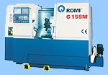  Main motor - 15 hp  Head motor - 5 hp  Chuck diameter 175 mm
Output Format
[x] ISO (G & M code) [ ] Conversational [ ] Other
Axis Designation
- Linear Axis
[x] X [ ] Y [x] Z [ ] U [ ] V [ ] W
- Rotary Axis
Fourth Axis [ ] A [ ] B [ ] W [x] C Plane [x] XY [ ] YZ [ ] ZX
[ ] Rotary Table [ ] Rotary Head Limits [ ] / [ ]
Fifth Axis [ ] B [ ] C Plane [ ] XY [ ] YZ [ ] ZX
[ ] Rotary Table [ ] Rotary Head Limits [ ] / [ ]

Units
[x] MM [ ] POL

Circular Interpolation
[ ] I J K [ ] Absolute Value [x] Start Point to Center
[ ] Center to Start Point [ ] R

Minimum Radius [ 0,5 mm] Maximum Radius [ 9999,999 mm]
Minimum Arc Length [ 0,5 mm]

Canned Cycle
[x] ISO (G81,G82....) [ ] Other (as table below) [ ] Not Defined

 | NX Standard Cycle | Format
 | Cycle Drill
 | Cycle Drill Deep
 | Cycle Drill Break Chip
 | Cycle Bore
 | Cycle Bore Drag
 | Cycle Bore NoDrag
 | Cycle Tap

System Requirements

CAD/CAM System: | Unigraphics | Version: | NX 1 or newer

Operating System
[x] WinNT/2000 | [x] WinXP Pro | [ ] UNIX
Installation Procedures

INSTALLATION

Please, choose one of the following procedures:

- Using the “custom” directory (recommended):

  - Copy the {UGII_BASE_DIR}\mach\resource directory to {UGII_BASE_DIR}\mach\custom;
  - From {UGII_BASE_DIR}\mach\custom\resource\postprocessor directory, delete all “*.tcl” e “*.def” files , except the “ugpost_base.tcl” file;
  - Copy the supplied files (*.pui”, “*.tcl” and “*.def) to the UGII_BASE_DIR}\mach\custom\resource\postprocessor directory;
  - In the same directory, edit the “template_post.dat” file, and insert the following line:
<name>, ${UGII_CAM_POST_DIR}”supplied Tcl file”,${UGII_CAM_POST_DIR}”supplied Def file”
  - From {UGII_BASE_DIR}\mach\custom\resource\use_def_event directory, edit the “ude.cdl” file, and copy/paste the content of the “ude.txt” file after the word “MACHINE”.
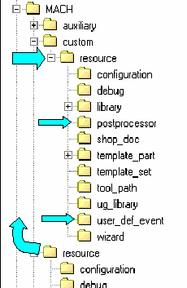
  - From {UGII_BASE_DIR}\UGII directory, edit the “ugii_env.dat” file and do the follwoing modifications:
- search for the variable UGII_CAM_RESOURCE_DIR definition line and comment it, inserting a “#” character: ➔#UGII_CAM_RESOURCE_DIR=${UGII_CAM_BASE_DIR}resource\ ;
- then, insert the following line:
UGII_CAM_RESOURCE_DIR=${UGII_CAM_CUSTOM_DIR}resource\
Using the standard “RESOURCE” directory:

  - Copy the supplied files (*.pui”, “*.tcl” and “*.def) to the {UGII_BASE_DIR}\mach\resource\postprocessor, directory;
  - In the same directory, edit the “template_post.dat” file, and insert the following line:
<name>, ${UGII_CAM_POST_DIR}”supplied Tcl file”,${UGII_CAM_POST_DIR}”supplied Def file”
  - From {UGII_BASE_DIR}\mach\resource\use_def_event directory, edit the “ude.cdl” file, and copy/paste the content of the “ude.txt” file after the word “MACHINE”.

Special Command

To get the right output, please follow the procedure below:

- The operations must be grouped in programs considering the type of cut operation (see the right side picture). | 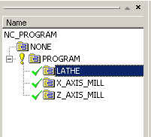
- Each program must have a HEAD Start Command that will be used to define the right postprocessor:
  - Turn
  - X-axis Head Position
  - Z-axis Head Position

Turn: | Z-axis Head Position:
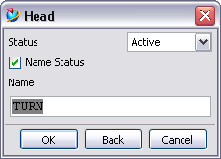 | 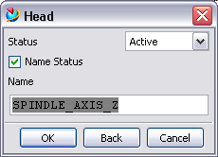

X-axis Head Position:
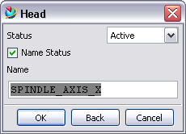
- To generate only one CNC program containing all cut operations, create a main program group and place the operations inside of it.
Created by:

- Unigrapnics Solutions do Brasil Ltda.

Contscts:

- Technical: |  | (11) 4224-7123
- Comercial |  | (11) 4224-7111

